[***https://thewaltdisneycompany.com/the-walt-disney-company-announces-strategic-reorganization-of-its-media-and-entertainment-businesses/***](https://thewaltdisneycompany.com/the-walt-disney-company-announces-strategic-reorganization-of-its-media-and-entertainment-businesses/)

***“The mission of The Walt Disney Company is to entertain, inform and inspire people around the globe through the power of unparalleled storytelling, reflecting the iconic brands, creative minds and innovative technologies that make ours the world’s premier entertainment company.”[1]***

**2) Strategic Firm Analysis**   
Next step is to assess the current status of the firm

* Describe the nature and attributes of the Company’s strategic approach to the market/industry as you see it.
  + - Timing: **COVID-19 pandemic**
    - Established brand name for family-friendly entertainment with a loyal customer base
    - Repurpose content to connect to audiences in new way (streaming)
    - Expanding on content that resonates: new stories and shows with beloved characters and franchises that people know and love; sense of nostalgia; using characters that people feel a strong emotional connection to
      * Mandalorian
      * Mulan, Cinderella
    - Easy entry points: $7.99 per month, bundles Hulu and ESPN+ for $14 per month
      * Increased price for reasons pertaining to inflation rather than profit growth
      * Hulu with ads started around $6.99 → lowered price to $5.99
      * Hulu no ads
      * Hulu live tv $64
    - Vast library of different genres: Marvel, Lucas (Star Wars), National Geographic, Pixar, Hotstar, and 21st Century Fox,
    - Addition of VR Movie Medium
      * <https://www.disneymoviesvr.com/>
* Describe how the company’s strategic approach is reflected in key operational aspects of the company’s business
  + **Operational Aspects** Disney focuses on competitiveness for their organization structure in order to stay on top of the market and gain managerial control of their product and services. Disney’s segmentation of different business types allows them to focus on a specific type of business within a certain industry, all while having a centralized control for each. The centralization of each business type segment enforces focus on a specific production. Due to the tremendous success of Disney’s direct-to-consumer business (Disney+, Hulu, ESPN+), the company has reorganized its media and entertainment businesses to further accelerate their DTC strategy. Disney’s creative engines will focus primarily on producing original content for the company’s streaming services, while activities concerning the global distribution and commercialization will be overseen by Disney’s newly centralized Media and Entertainment Distribution organization (DMED). The DMED group is responsible for monetizing all content and overseeing operations of Disney’s streaming services. This organization is solely accountable for the Profits and Losses for Disney’s media and entertainment businesses. Studios, General Entertainment, and Sports are the three distinct content creation groups led by Alan Horn & Alan Bergman, Peter Rice, and James Pitaro, respectively. This separation of content creation from distribution allows for Disney to become faster and more effective in the development of the content that consumers want the most and in the way consumers prefer to receive that content. In light of this reorganization, Disney aims to support their growth strategy and increase shareholder value ([1](https://thewaltdisneycompany.com/the-walt-disney-company-announces-strategic-reorganization-of-its-media-and-entertainment-businesses/))).Although content creation and distribution segments are distinct from one another, the integration of both comes from the centralization in Disney’s HQ, which requires disciplined managerial control.   
     Disney’s business type segmentation allows for the development of unique products to be offered to many different market segments. In other words, this helps with their strategy of product differentiation. Disney’s strong marketing presence helps raise funds across all segments. With the acquisition of BAMTech, a streaming platform, Disney was then able to develop two subscription-based streaming services: ESPN+ (sports-oriented) and Disney+ (entertainment-oriented). When Disney acquired Fox, this allowed them to partner with Hotstar and infiltrate the South East Asia market. The purchase of Marvel allowed access to a giant library of content. Disney’s acquisitions and partnerships helped further their customer growth and overall expansion.
  + <https://thewaltdisneycompany.com/the-walt-disney-company-announces-strategic-reorganization-of-its-media-and-entertainment-businesses/>
  + [Walt Disney Company's Organizational Structure for Synergistic Diversification](http://panmore.com/walt-disney-company-organizational-structure-synergistic-diversification) (includes recommendations )
    - They focus on competitiveness for their organizational structure to stay on top of the market and gain managerial control of their product and services
    - Business type segments
      * Allows the main focus on a certain type of business of industry
        + Theme park and entertainment management are separate
        + Then centralization helps focus on a specific production rather than both the theme park and entertainment
        + Divided into Media Networks, Park and Resorts, Studio entertainment, and consumer products and interactive media
    - Functional groups
      * Focus on multidivisional strategies by using centralized control
    - Geographical divisions
      * Focus on geographics of local, domestic, and regional markets
      * Allows for expansion globally
    - cooperative -M (multidivisional); involving related constrained diversification (williams,1)
    - Diversity - cultures and traditions
    - Centralization in Disney HQ; disciplined managerial controls when it comes to social media, theme parks, and entertainment
    - ** product differentiation is key strategy: [Disney's Generic Competitive Strategy & Intensive Growth Strategies](http://panmore.com/disney-generic-competitive-strategy-intensive-growth-strategies)
      * Unique products offered to many market segments
* Analyze whether the company is well-positioned for the future or not: does it have a sustainable advantage? If so:
  + **Position for Future**  
     Disney’s sustainable advantage pertains to their emphasis on product differentiation, innovation and creativity, as well as their successful integration between products, thus they are well-positioned for the future. Due to their strong focus on innovation, they are able to produce high-quality and unique content contributing to the differentiation of the company’s products from competitors. Disney’s centralized integration technique further advances their business segments by providing a linkage between them. This product integration also contributes to their marketing strategy efforts which reinforces the uniqueness of the company’s brand.
  + Disney is able to offer unique products to many different market segments. For example, the corporation offers its entertainment products to practically every person in the world, especially with the core emphasis on family-oriented programming.
  + Identify and analyze the sources of these advantages
    - Product differentiation
    - Strong focus on innovation and creativity
    - Integration between products
  + Discuss how these advantages relate to the strategic objectives of the company
    - Marketing strategies that reinforce uniqueness of company’s brand :<http://panmore.com/walt-disney-company-marketing-mix-4ps-analysis>
* **2b) Strategic Firm Analysis** (Radhey + Angela)  
  Key concepts to consider – and include in your assessment if they are relevant include:
* <https://www.hotstar.com/us/privacy-policy#par18> -
  + Innovation – and how it has or has not been innovative
    - Addition of VR Movie Medium
      * <https://www.disneymoviesvr.com/>
  + Analytics – any specific application beyond typical
    - <https://databricks.com/blog/2020/12/14/learn-how-disney-built-their-streaming-data-analytics-platform-with-databricks-and-aws-to-improve-the-customer-experience.html>
  + Platform – is it a platform play?
    - Yes
    - Use network effect for Group viewing Parties
  + Social strategies – relevant? Important?
    - Disney has a vast and loyal customer base, which they were able to capitalize on through their social strategies. Disney Games and Interactive Experiences oversees various websites and interactive media owned by the Walt Disney Company and helps connect Disney enthusiasts across the world. Disney’s presence on Twitter is mainly utilized as a destination for real time conversations with their customers, while they use Instagram for quick visual marketing/informational pieces and Facebook for longer videos. Not only do they use popular methods of social media, but they also organize Disney-themed running events.
    - Disney+ Party; Group viewing parties (up to 7 people): <https://thedisneyplusparty.com>
    - Disney Runs
      * <https://www.rundisney.com/events/disneyworld/star-wars-rival-run-weekend/>
    - Twitter - destination for real time conversations; Instagram - visual pieces; Facebook - long form videos → <https://shortyawards.com/13th/disney>
    - Disney Interactive (connecting with Disney enthusiasts)? - <https://digiday.com/marketing/inside-disneys-social-strategy/>
  + Long tail as a part of their strategy or opportunity?
    - Access to emerging markets- South, South East and East Asia (Key demographic)
  + Versioning – do they offer versions? Should they?
    - Disney top streaming services include Disney+, Hulu, and ESPN+. Disney+ is more family-oriented including all movies and shows rated PG-13 and below. Hulu acts as their platform for more adult content. There are many different pricing versions of Hulu available and some are bundled with their other streaming services.
  + Standards or dominant design
    - Since Disney+ was late to the streaming service industry, they were not the pioneers in setting user experience dominant designs; however, with their vast library and variety of genres, they are definitely setting a societal standard for an assortment of options.

[Disney Plus Revenue and Usage Statistics (2020)](https://www.businessofapps.com/data/disney-plus-statistics/)

[Disney Plus: Inside the Ambitious Plans for the Streaming Service](https://variety.com/2019/biz/features/disney-plus-streaming-plans-bob-iger-1203120734/)

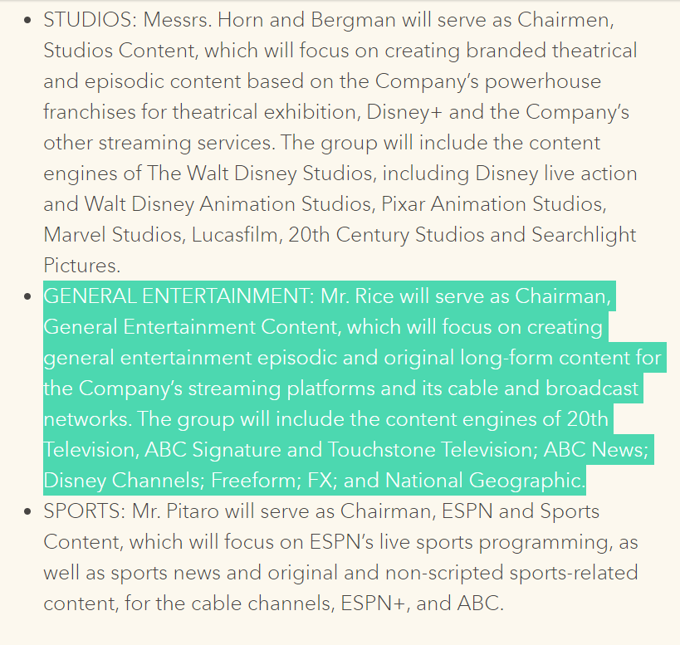



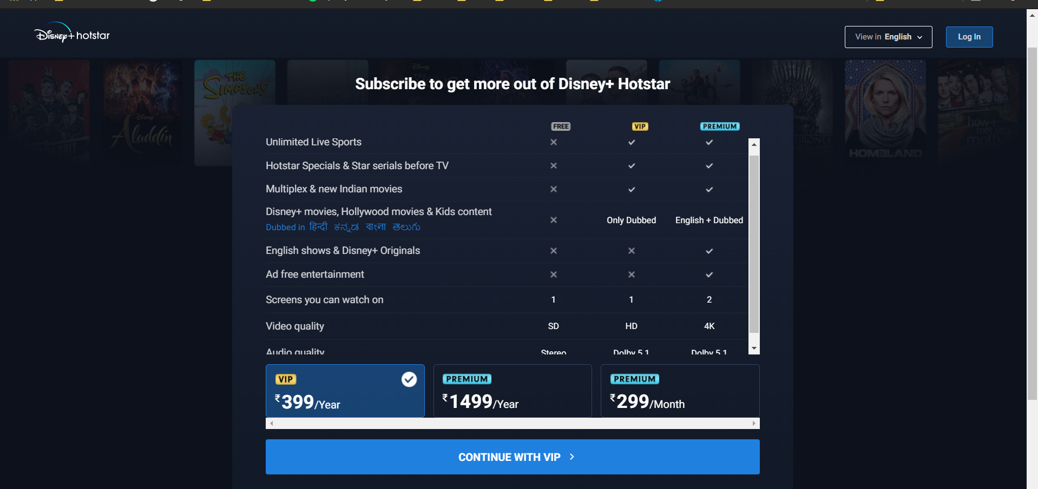

1. <https://thewaltdisneycompany.com/about/#:~:text=The%20mission%20of%20The%20Walt,the%20world's%20premier%20entertainment%20company>.